**Overview**

* **Service Name:** Apportion Service
* **Upgrade Date:** 25 July 2025
* **Performed By:** Parvesh Mishra NUDM Team

curl --location 'http://localhost:8280/egf-master/accountcodepurposes/_search?tenantId=pg.citya' \

--header 'Content-Type: application/json' \

--data '{

"requestInfo": {

"apiId": "string",

"ver": "string",

"ts": 0,

"action": "string",

"did": "string",

"key": "string",

"msgId": "string",

"authToken": "string",

"correlationId": "string",

"plainAccessRequest": {

"recordId": "string",

"plainRequestFields": [

"string"

]

},

"userInfo": {

"id": 0,

"userName": "string",

"name": "string",

"type": "string",

"mobileNumber": "string",

"emailId": "string",

"roles": [

{

"id": 0,

"name": "string",

"code": "string",

"tenantId": "string"

}

],

"tenantId": "string",

"uuid": "string"

}

},

"suppliers": [

{

"id": "string",

"code": "string",

"name": "string",

"address": "string",

"mobile": "string",

"email": "string",

"description": "string",

"active": true,

"panNo": "string",

"tinNo": "string",

"registationNo": "string",

"bankAccount": {

"id": "string",

"bankBranch": {

"id": "string",

"bank": {

"id": "string",

"code": "string",

"name": "string",

"description": "string",

"active": true,

"type": "string",

"tenantId": "string",

"createdBy": {

"id": 0,

"userName": "string",

"name": "string",

"type": "string",

"mobileNumber": "string",

"emailId": "string",

"roles": [

{

"id": 0,

"name": "string",

"code": "string",

"tenantId": "string"

}

],

"tenantId": "string",

"uuid": "string"

},

"lastModifiedBy": {

"id": 0,

"userName": "string",

"name": "string",

"type": "string",

"mobileNumber": "string",

"emailId": "string",

"roles": [

{

"id": 0,

"name": "string",

"code": "string",

"tenantId": "string"

}

],

"tenantId": "string",

"uuid": "string"

},

"createdDate": "2025-08-05T11:13:01.350Z",

"lastModifiedDate": "2025-08-05T11:13:01.350Z",

"deleteReason": "string"

},

"code": "string",

"name": "TeGRODNrWJlEb__WcbCZRnviu9QeMXFUb4ytbnxelWwiLd",

"address": "string",

"address2": "string",

"city": "string",

"state": "string",

"pincode": "string",

"phone": "string",

"fax": "string",

"contactPerson": "string",

"active": true,

"description": "string",

"micr": "string",

"tenantId": "string",

"createdBy": {

"id": 0,

"userName": "string",

"name": "string",

"type": "string",

"mobileNumber": "string",

"emailId": "string",

"roles": [

{

"id": 0,

"name": "string",

"code": "string",

"tenantId": "string"

}

],

"tenantId": "string",

"uuid": "string"

},

"lastModifiedBy": {

"id": 0,

"userName": "string",

"name": "string",

"type": "string",

"mobileNumber": "string",

"emailId": "string",

"roles": [

{

"id": 0,

"name": "string",

"code": "string",

"tenantId": "string"

}

],

"tenantId": "string",

"uuid": "string"

},

"createdDate": "2025-08-05T11:13:01.350Z",

"lastModifiedDate": "2025-08-05T11:13:01.350Z",

"deleteReason": "string"

},

"chartOfAccount": {

"id": "string",

"glcode": "string",

"name": "string",

"accountCodePurpose": {

"id": "string",

"name": "string",

"tenantId": "string",

"createdBy": {

"id": 0,

"userName": "string",

"name": "string",

"type": "string",

"mobileNumber": "string",

"emailId": "string",

"roles": [

{

"id": 0,

"name": "string",

"code": "string",

"tenantId": "string"

}

],

"tenantId": "string",

"uuid": "string"

},

"lastModifiedBy": {

"id": 0,

"userName": "string",

"name": "string",

"type": "string",

"mobileNumber": "string",

"emailId": "string",

"roles": [

{

"id": 0,

"name": "string",

"code": "string",

"tenantId": "string"

}

],

"tenantId": "string",

"uuid": "string"

},

"createdDate": "2025-08-05T11:13:01.350Z",

"lastModifiedDate": "2025-08-05T11:13:01.350Z",

"deleteReason": "string"

},

"description": "string",

"isActiveForPosting": true,

"parentId": "string",

"type": "string",

"classification": 0,

"functionRequired": true,

"budgetCheckRequired": true,

"majorCode": "string",

"isSubLedger": true,

"tenantId": "string",

"createdBy": {

"id": 0,

"userName": "string",

"name": "string",

"type": "string",

"mobileNumber": "string",

"emailId": "string",

"roles": [

{

"id": 0,

"name": "string",

"code": "string",

"tenantId": "string"

}

],

"tenantId": "string",

"uuid": "string"

},

"lastModifiedBy": {

"id": 0,

"userName": "string",

"name": "string",

"type": "string",

"mobileNumber": "string",

"emailId": "string",

"roles": [

{

"id": 0,

"name": "string",

"code": "string",

"tenantId": "string"

}

],

"tenantId": "string",

"uuid": "string"

},

"createdDate": "2025-08-05T11:13:01.350Z",

"lastModifiedDate": "2025-08-05T11:13:01.350Z",

"deleteReason": "string"

},

"fund": {

"tenantId": "string",

"createdBy": {

"id": 0,

"userName": "string",

"name": "string",

"type": "string",

"mobileNumber": "string",

"emailId": "string",

"roles": [

{

"id": 0,

"name": "string",

"code": "string",

"tenantId": "string"

}

],

"tenantId": "string",

"uuid": "string"

},

"lastModifiedBy": {

"id": 0,

"userName": "string",

"name": "string",

"type": "string",

"mobileNumber": "string",

"emailId": "string",

"roles": [

{

"id": 0,

"name": "string",

"code": "string",

"tenantId": "string"

}

],

"tenantId": "string",

"uuid": "string"

},

"createdDate": "2025-08-05T11:13:01.350Z",

"lastModifiedDate": "2025-08-05T11:13:01.350Z",

"deleteReason": "string",

"id": "string",

"name": "string",

"code": "string",

"identifier": "string",

"level": 0,

"parent": "string",

"active": true

},

"accountNumber": "string",

"accountType": "string",

"description": "string",

"active": true,

"payTo": "string",

"type": "RECEIPTS",

"tenantId": "string",

"createdBy": {

"id": 0,

"userName": "string",

"name": "string",

"type": "string",

"mobileNumber": "string",

"emailId": "string",

"roles": [

{

"id": 0,

"name": "string",

"code": "string",

"tenantId": "string"

}

],

"tenantId": "string",

"uuid": "string"

},

"lastModifiedBy": {

"id": 0,

"userName": "string",

"name": "string",

"type": "string",

"mobileNumber": "string",

"emailId": "string",

"roles": [

{

"id": 0,

"name": "string",

"code": "string",

"tenantId": "string"

}

],

"tenantId": "string",

"uuid": "string"

},

"createdDate": "2025-08-05T11:13:01.350Z",

"lastModifiedDate": "2025-08-05T11:13:01.350Z",

"deleteReason": "string"

},

"ifscCode": "string",

"bank": {

"id": "string",

"code": "string",

"name": "string",

"description": "string",

"active": true,

"type": "string",

"tenantId": "string",

"createdBy": {

"id": 0,

"userName": "string",

"name": "string",

"type": "string",

"mobileNumber": "string",

"emailId": "string",

"roles": [

{

"id": 0,

"name": "string",

"code": "string",

"tenantId": "string"

}

],

"tenantId": "string",

"uuid": "string"

},

"lastModifiedBy": {

"id": 0,

"userName": "string",

"name": "string",

"type": "string",

"mobileNumber": "string",

"emailId": "string",

"roles": [

{

"id": 0,

"name": "string",

"code": "string",

"tenantId": "string"

}

],

"tenantId": "string",

"uuid": "string"

},

"createdDate": "2025-08-05T11:13:01.350Z",

"lastModifiedDate": "2025-08-05T11:13:01.350Z",

"deleteReason": "string"

},

"tenantId": "string",

"createdBy": {

"id": 0,

"userName": "string",

"name": "string",

"type": "string",

"mobileNumber": "string",

"emailId": "string",

"roles": [

{

"id": 0,

"name": "string",

"code": "string",

"tenantId": "string"

}

],

"tenantId": "string",

"uuid": "string"

},

"lastModifiedBy": {

"id": 0,

"userName": "string",

"name": "string",

"type": "string",

"mobileNumber": "string",

"emailId": "string",

"roles": [

{

"id": 0,

"name": "string",

"code": "string",

"tenantId": "string"

}

],

"tenantId": "string",

"uuid": "string"

},

"createdDate": "2025-08-05T11:13:01.350Z",

"lastModifiedDate": "2025-08-05T11:13:01.350Z",

"deleteReason": "string"

}

]

}'

**Note: localhost:8082 is locally & localhost:8090 is niuatt environment**

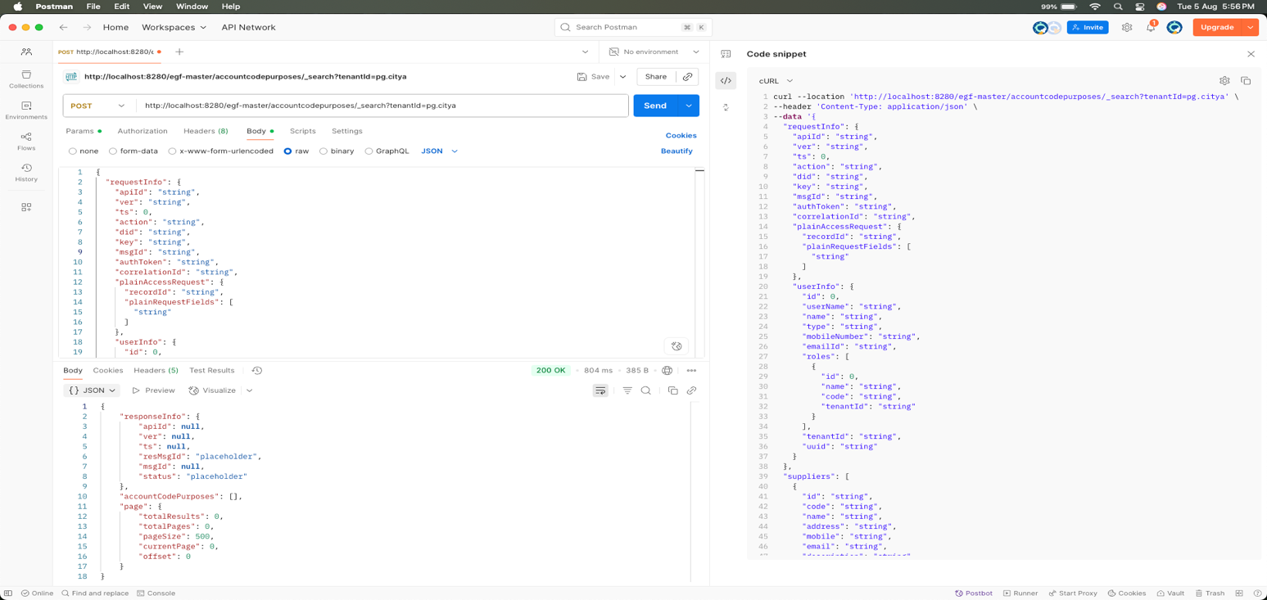

Response

{

"responseInfo": {

"apiId": null,

"ver": null,

"ts": null,

"resMsgId": "placeholder",

"msgId": null,

"status": "placeholder"

},

"accountCodePurposes": [],

"page": {

"totalResults": 0,

"totalPages": 0,

"pageSize": 500,

"currentPage": 0,

"offset": 0

}

}

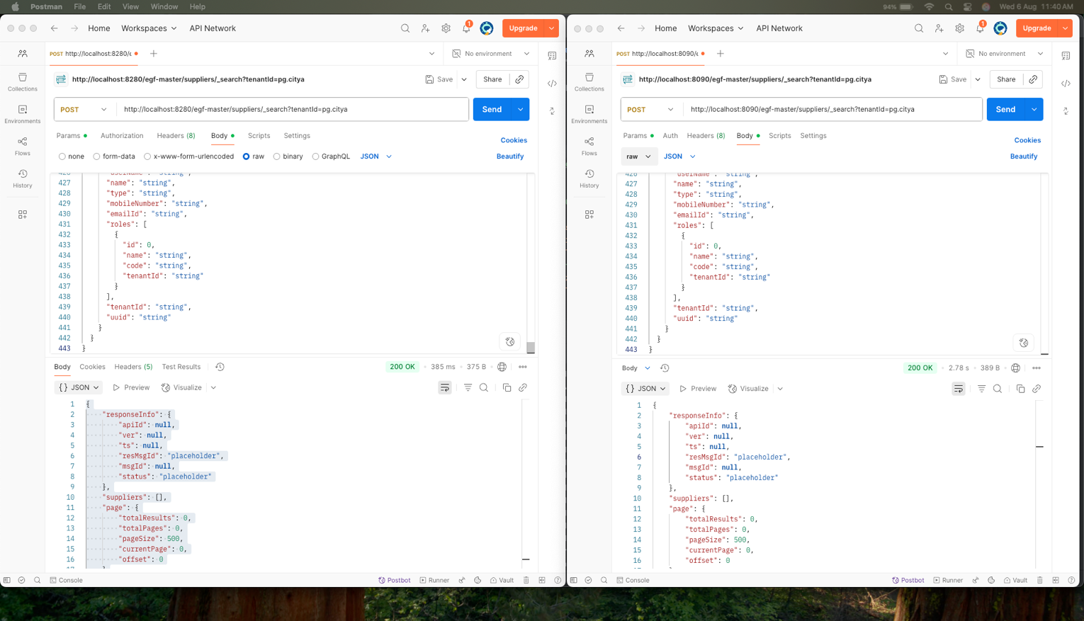

Response Compare

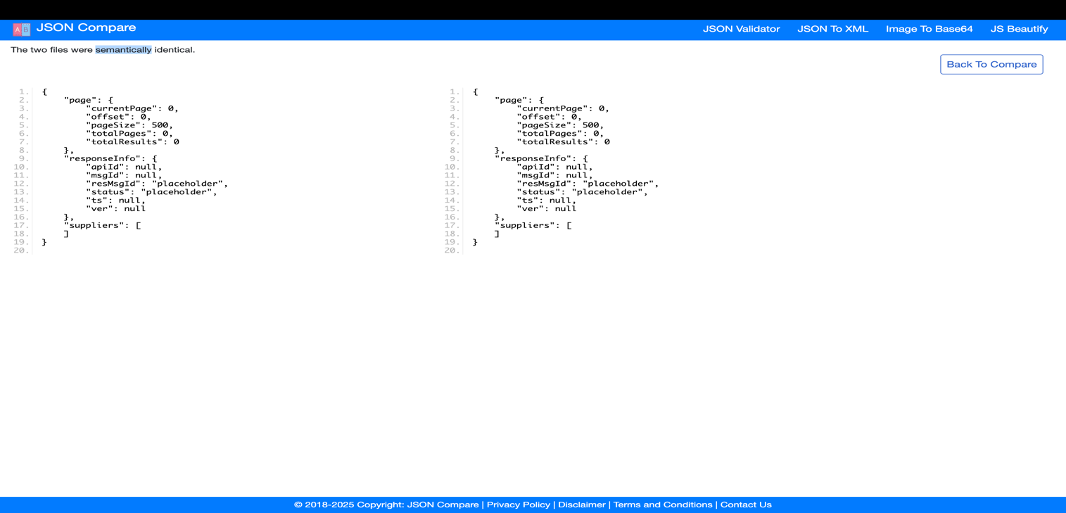

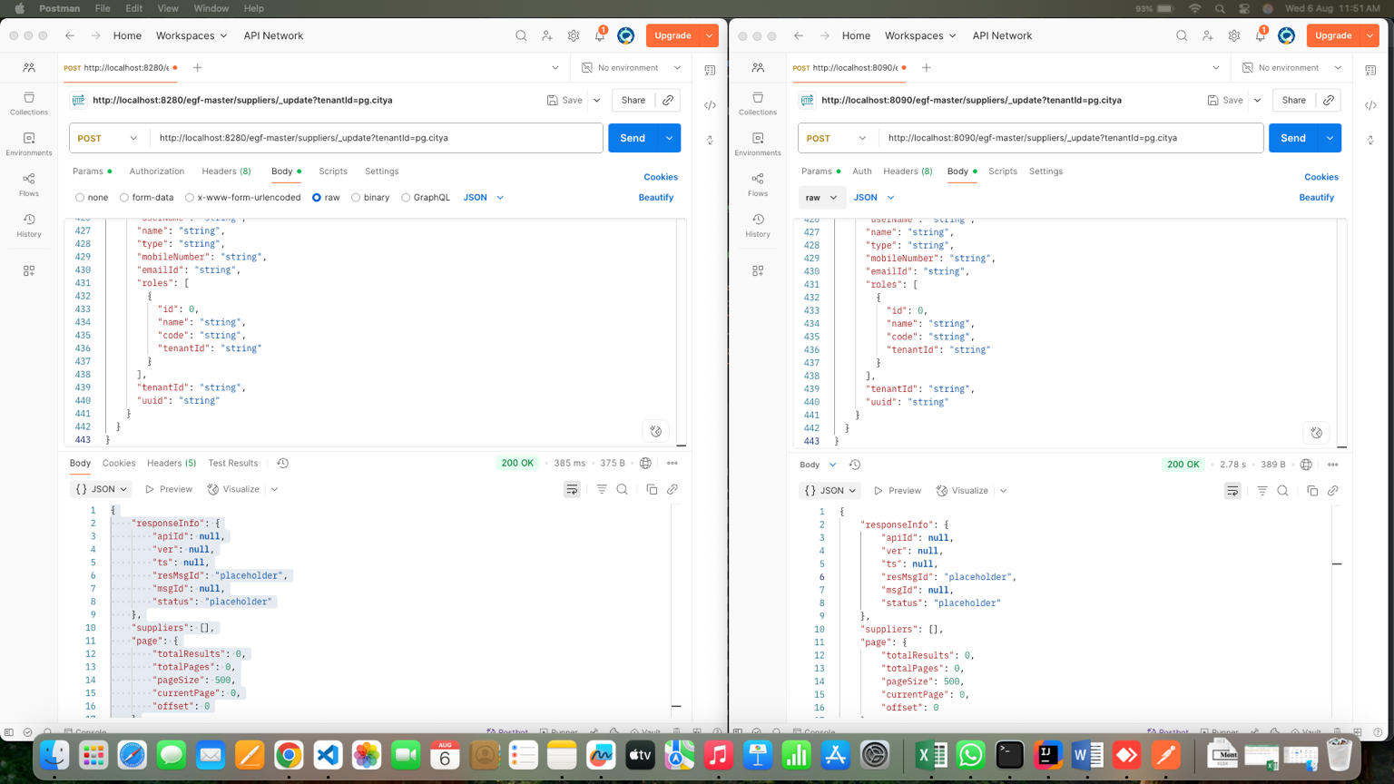

Response Compare

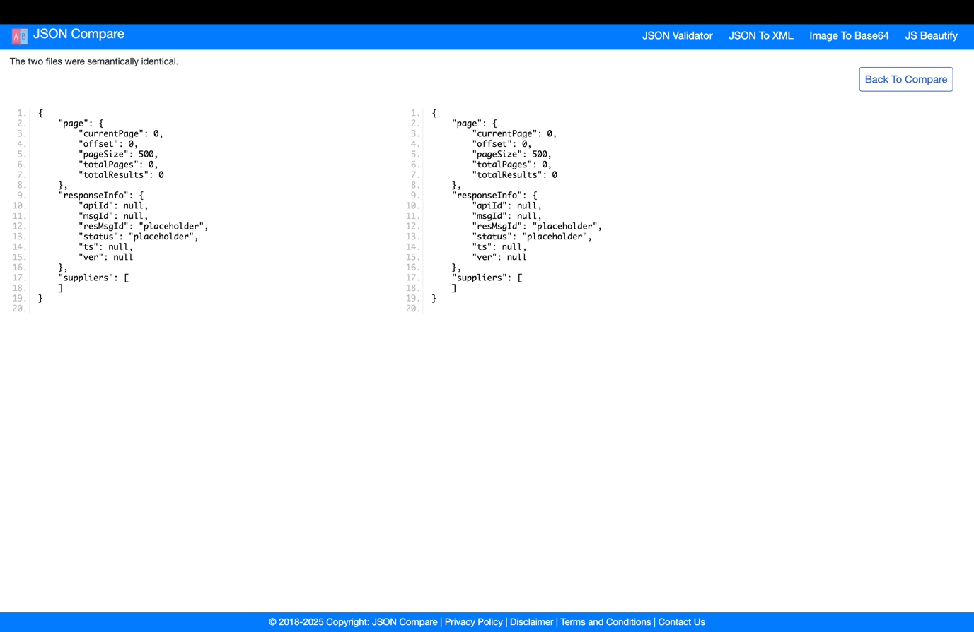

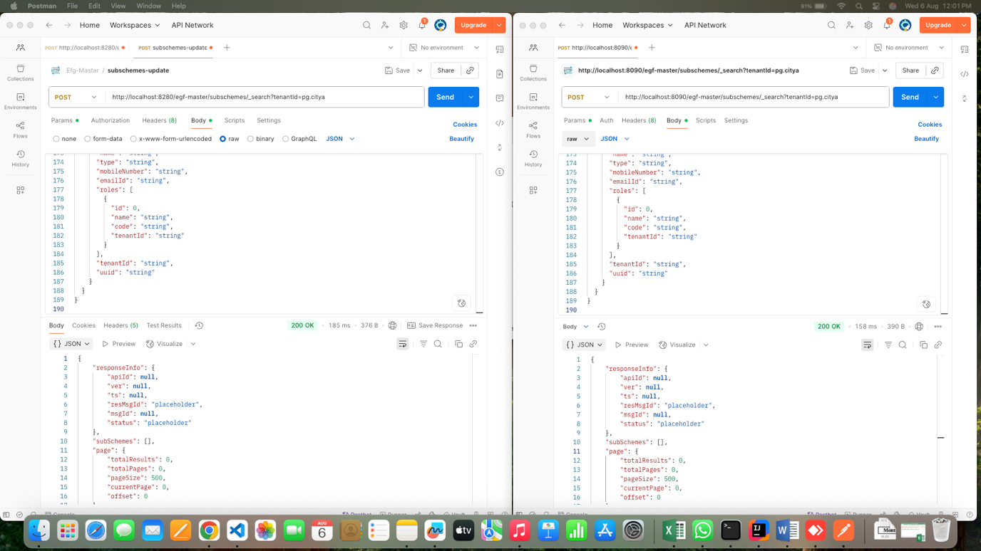

Respose Compare

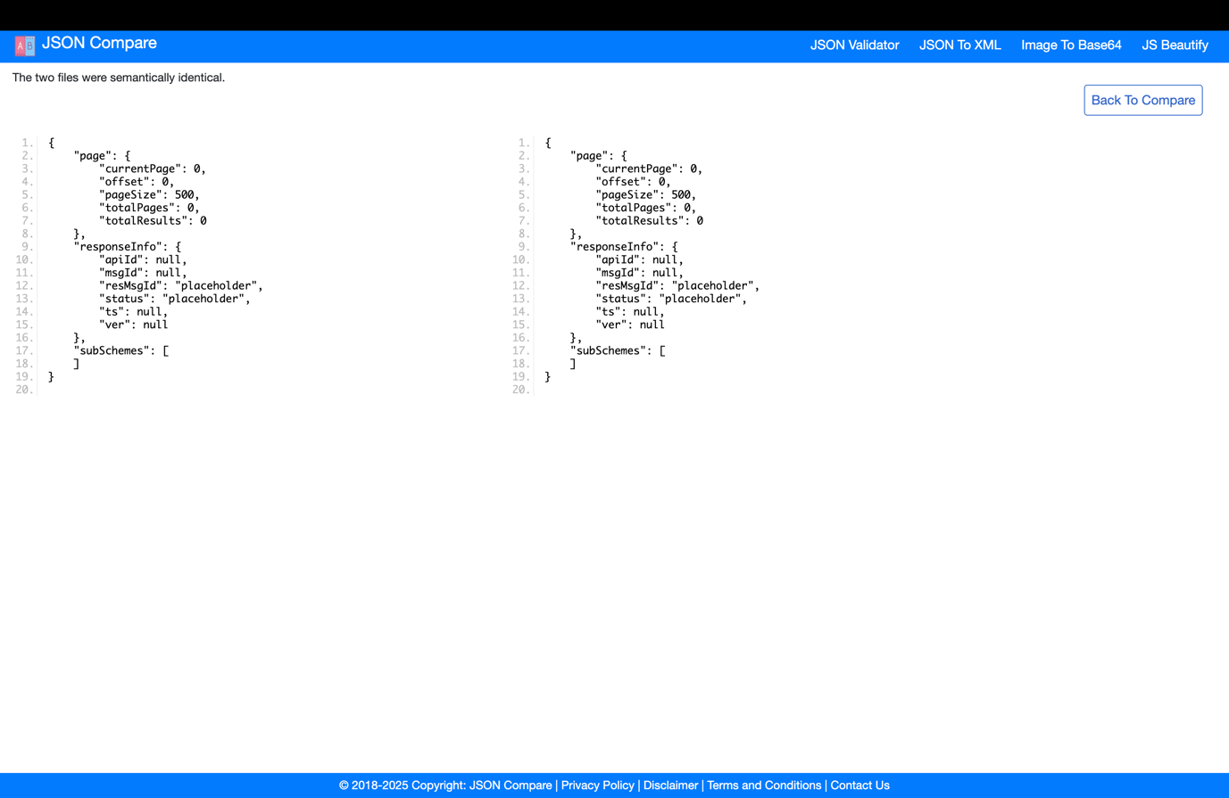

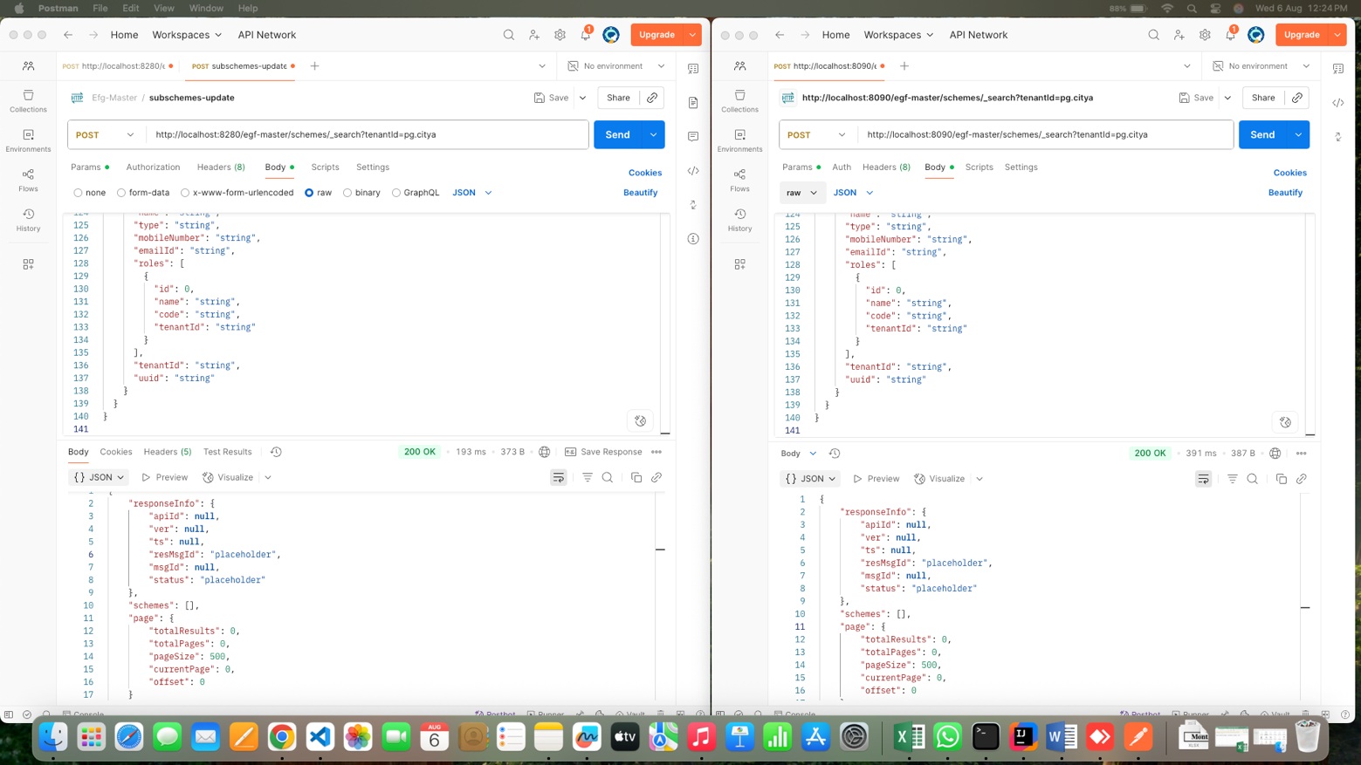

Response Compare

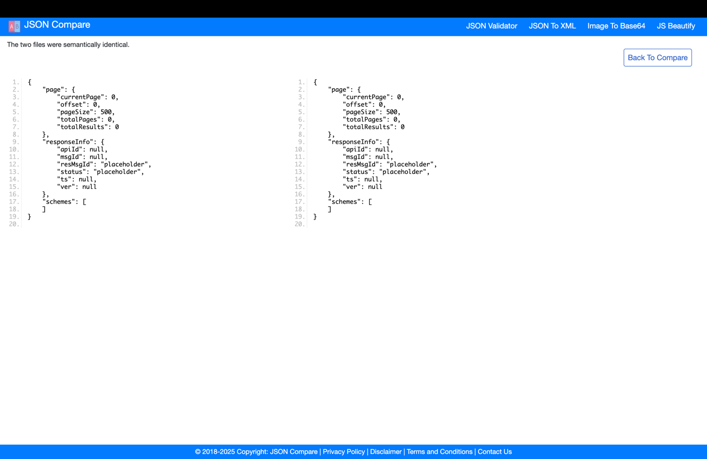

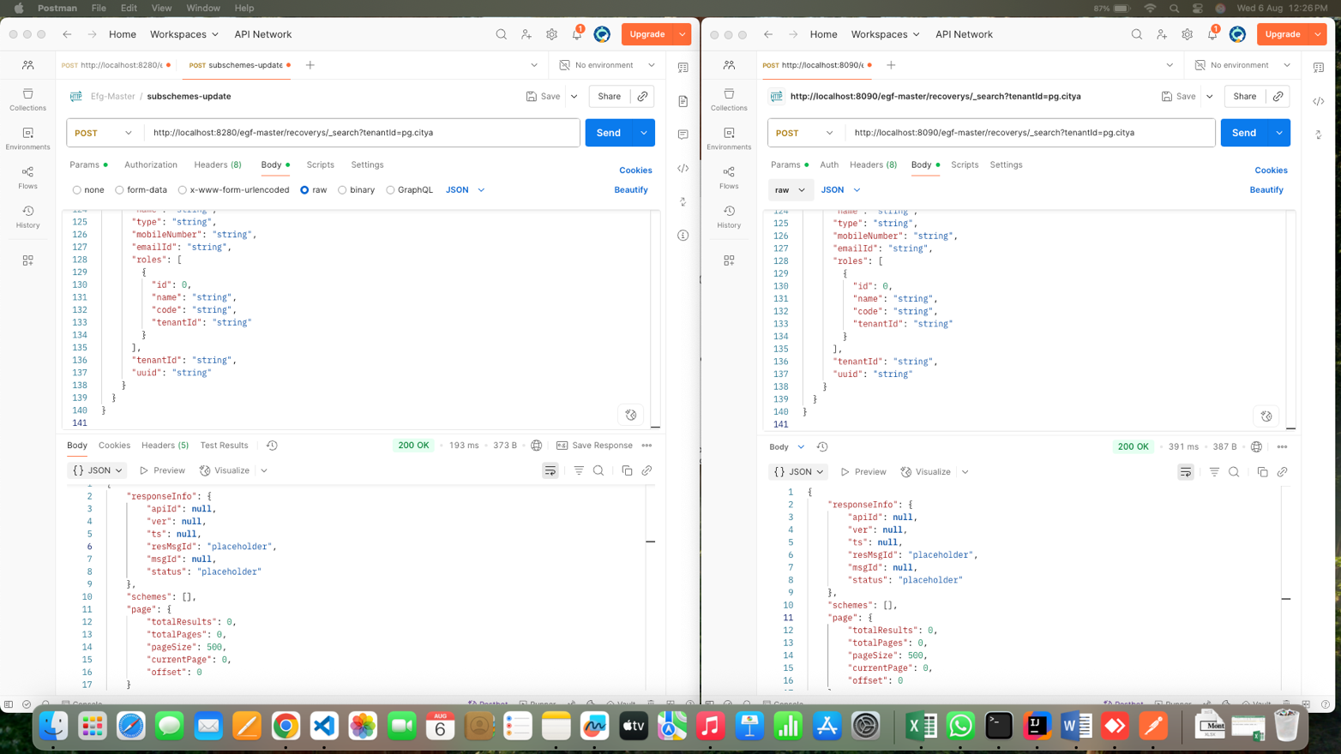

Response compare



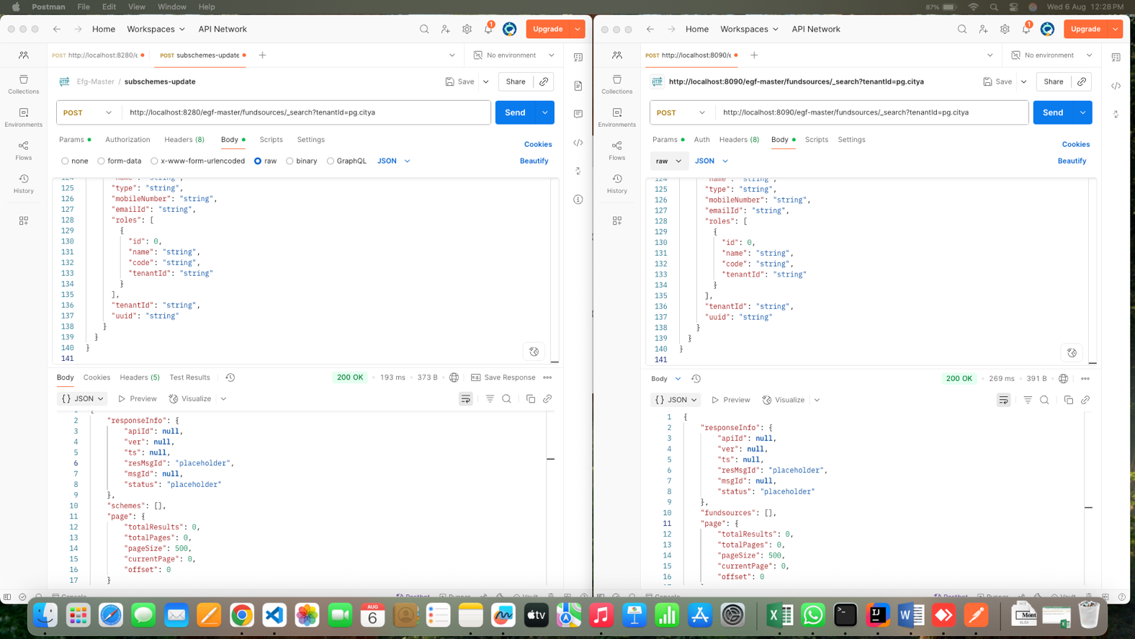

Response compare

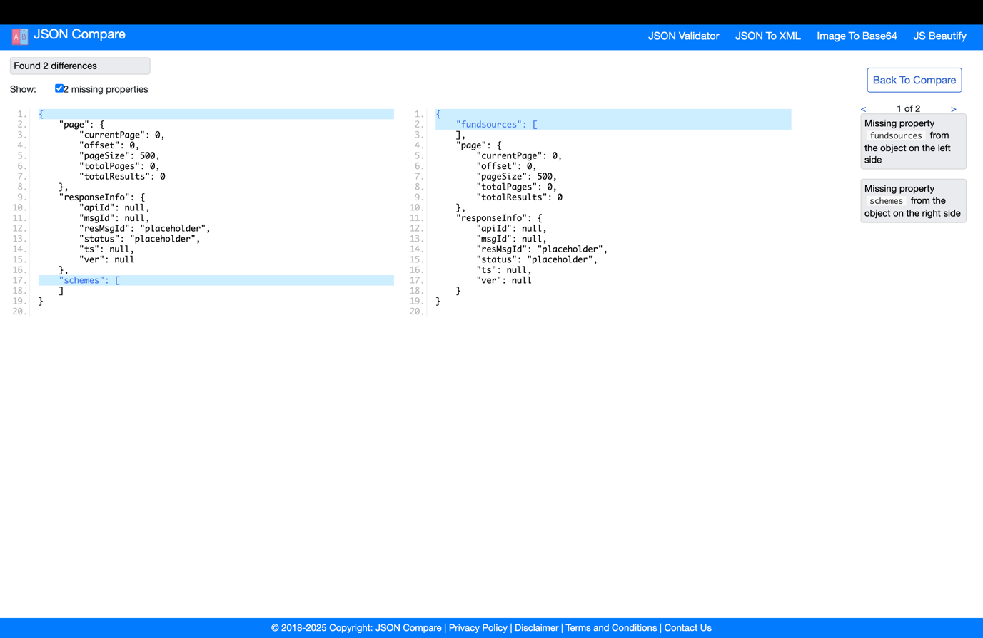

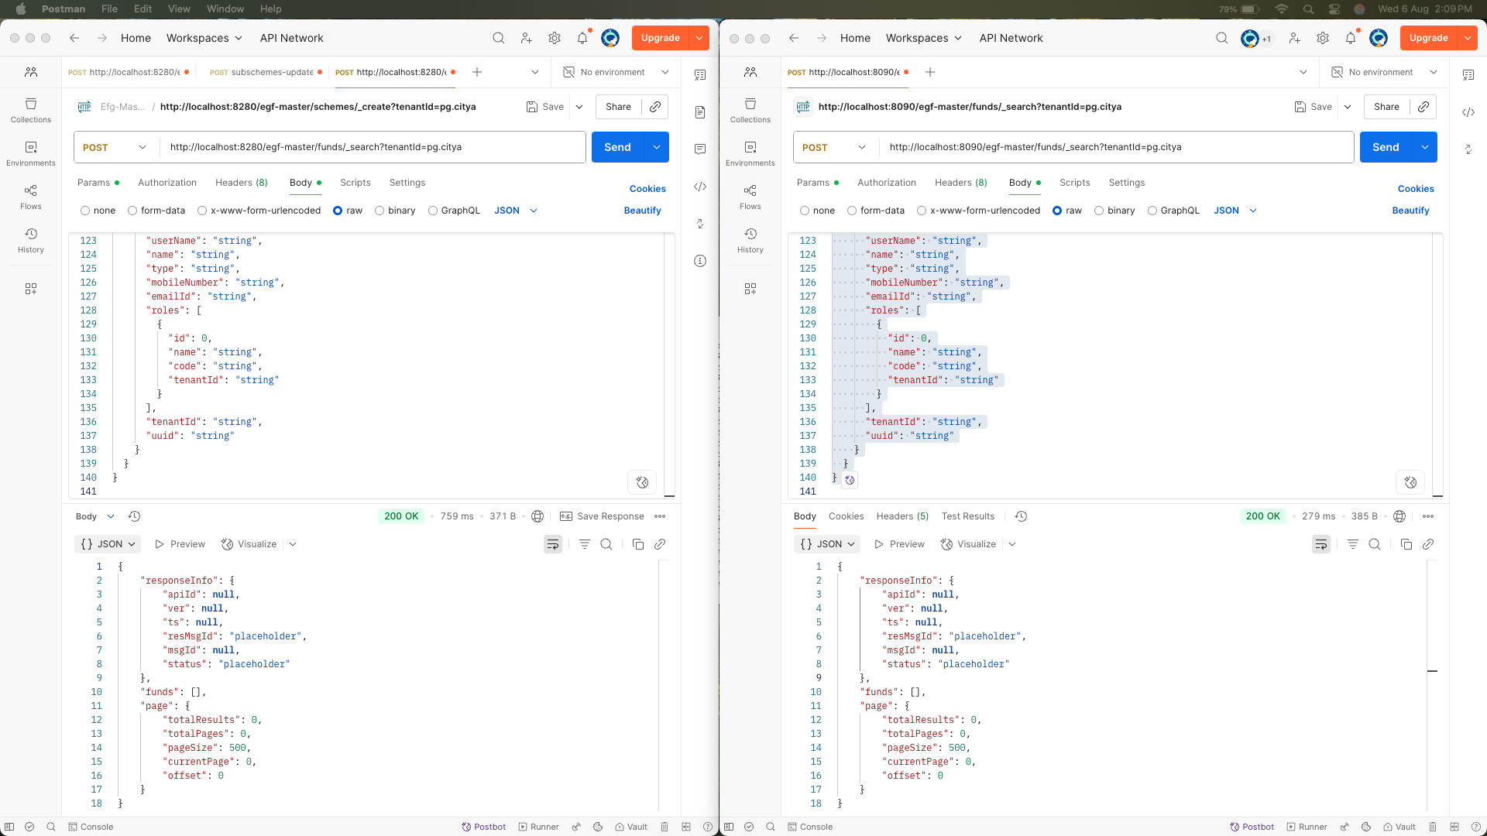

Response compare

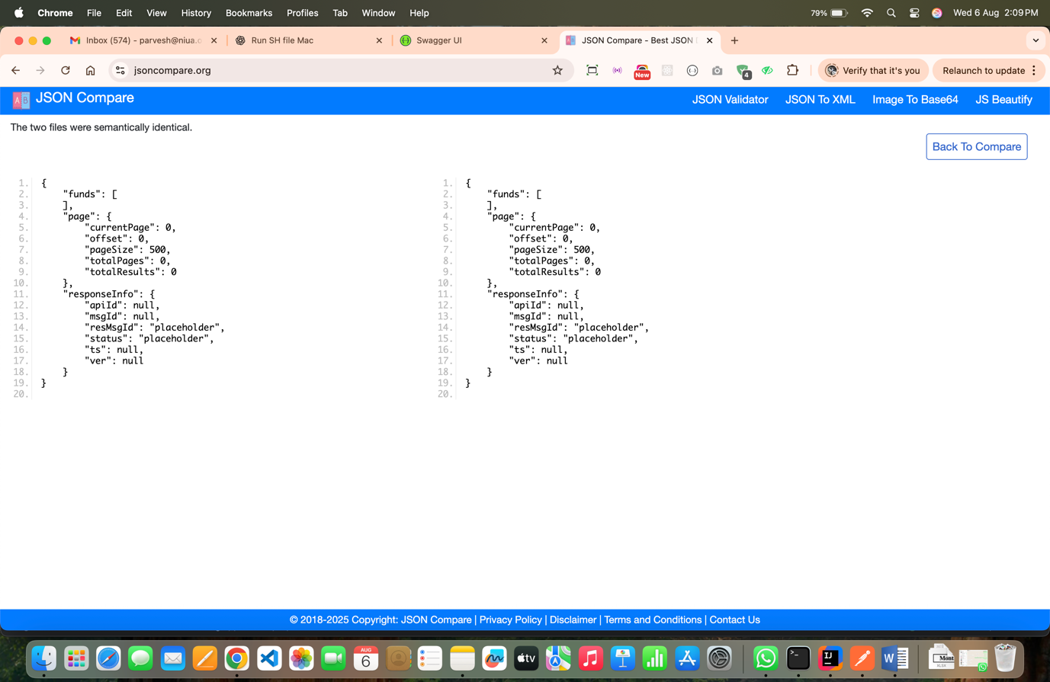

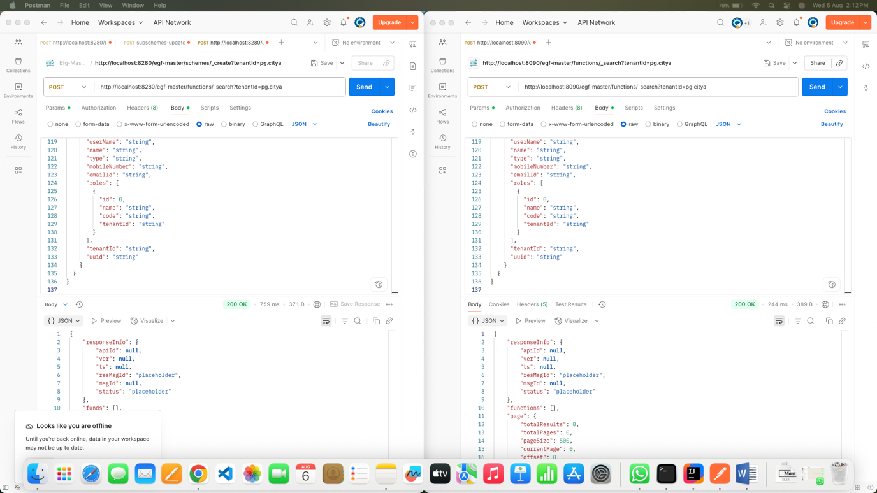

Response compare

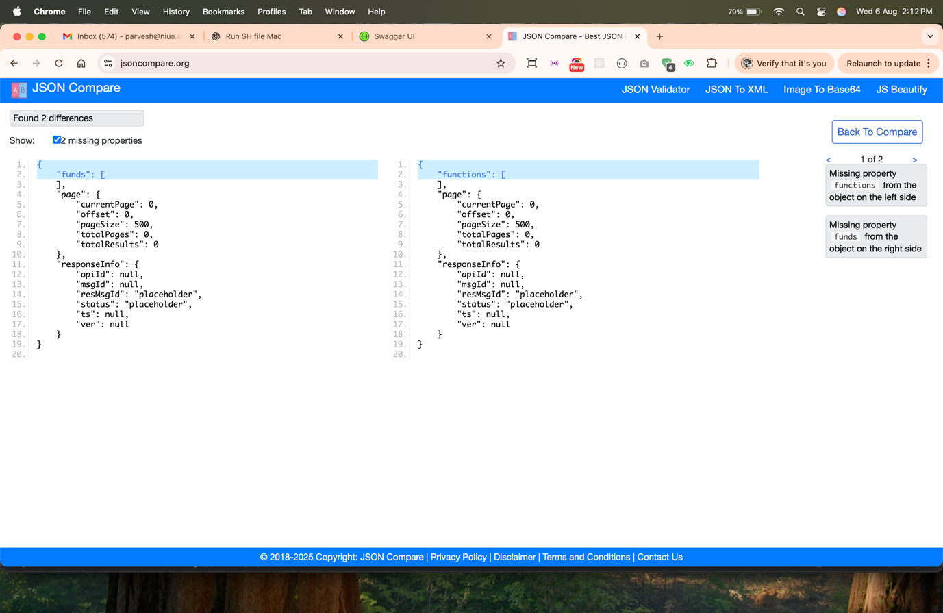

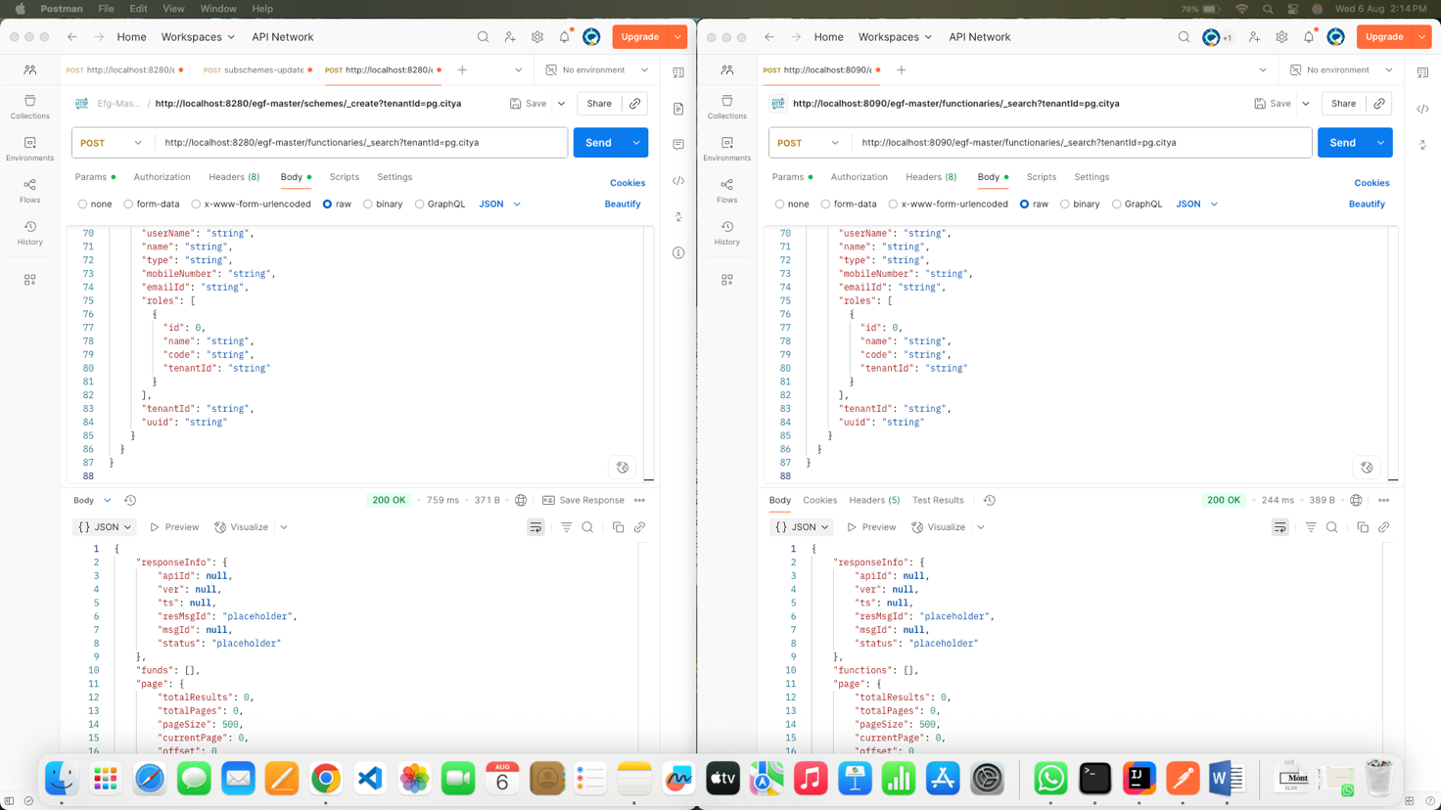

Response compare

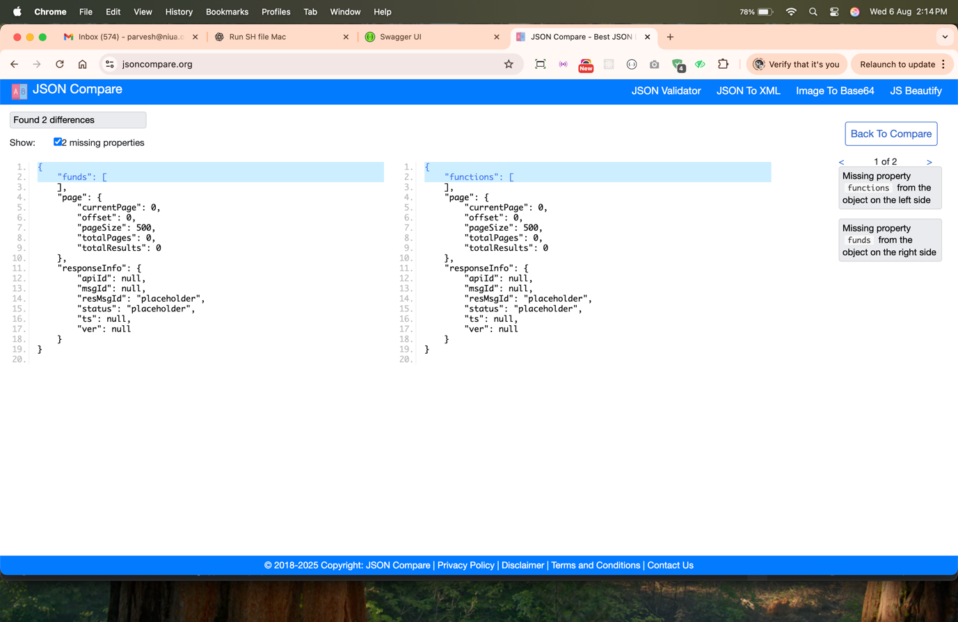

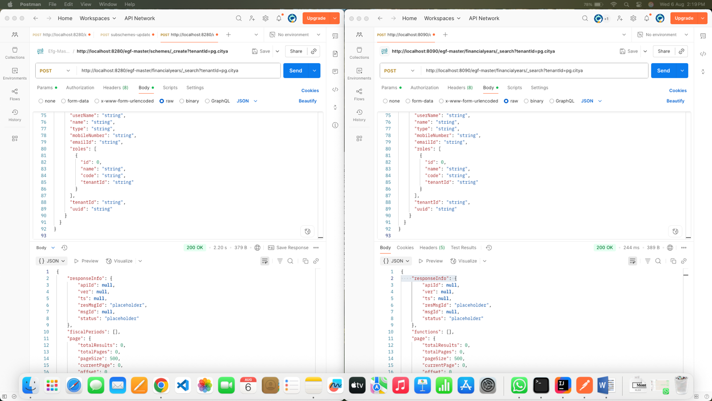

Response compare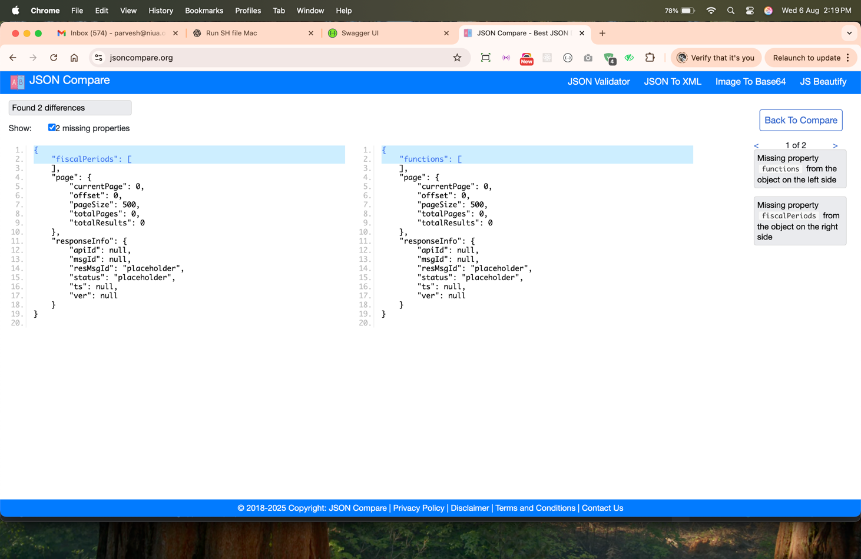

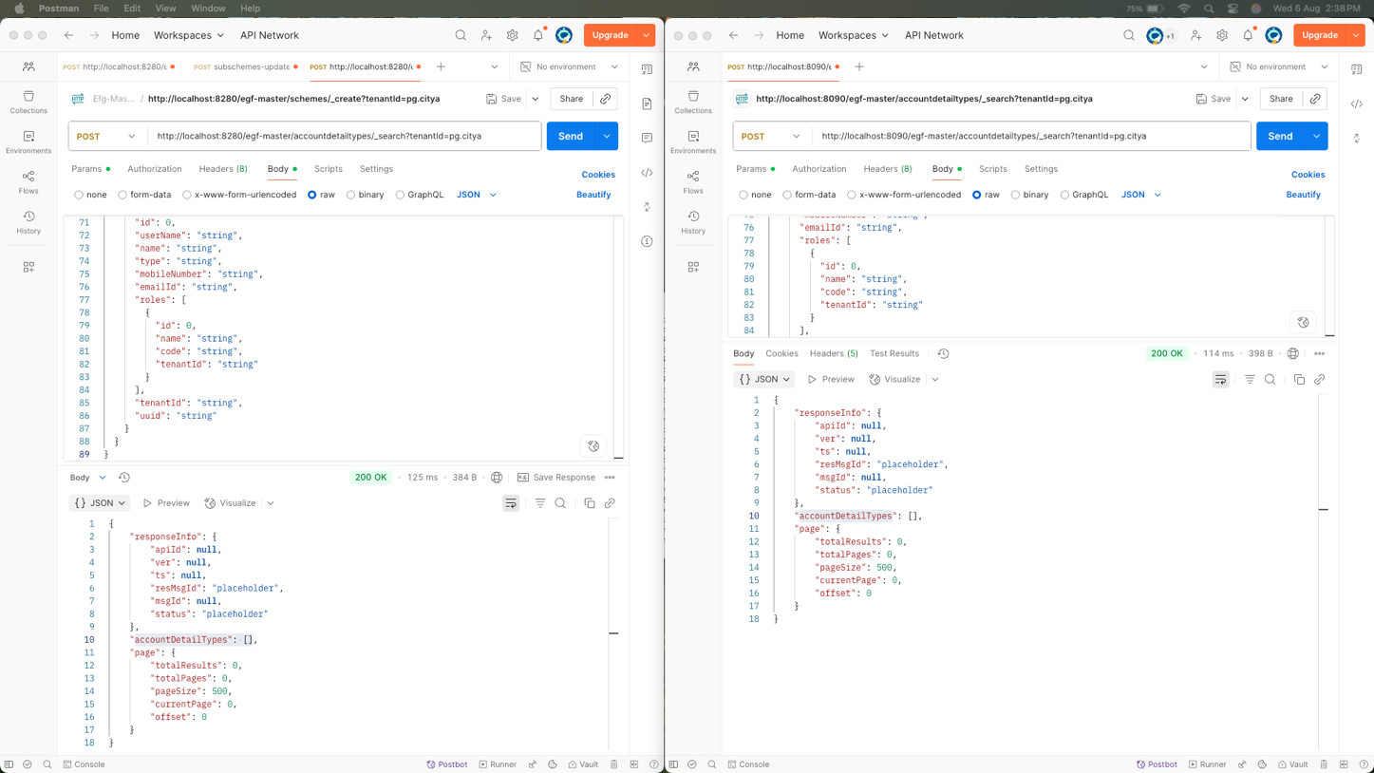

Response compare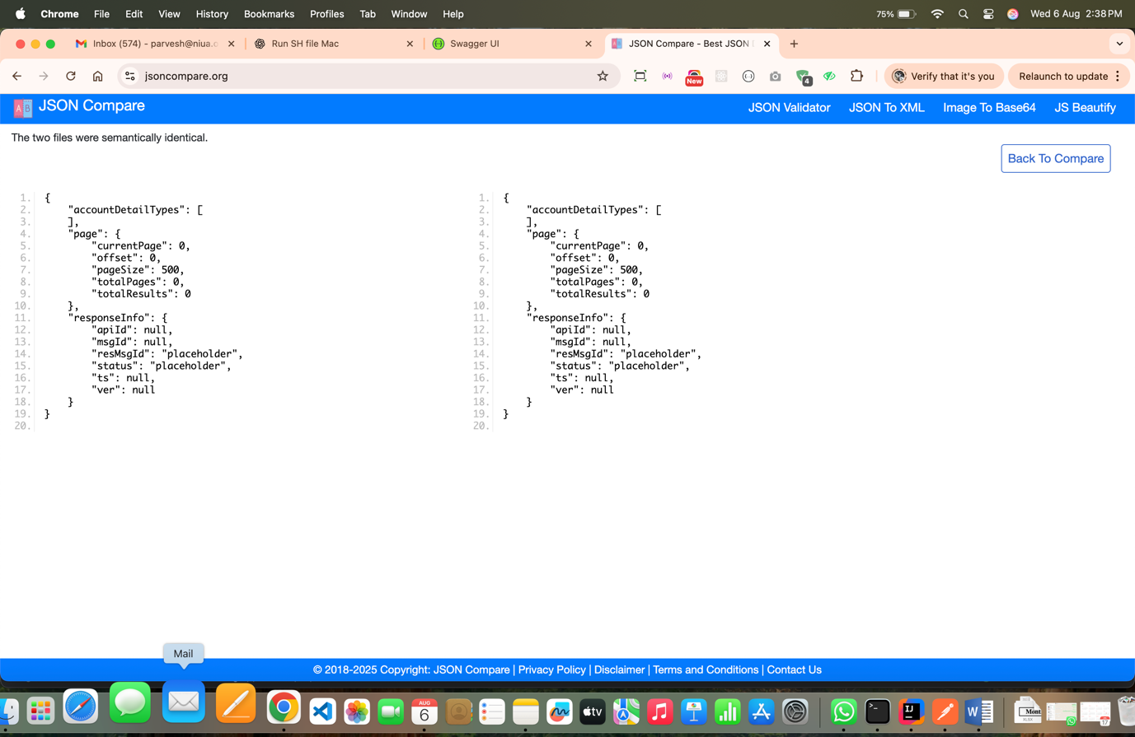

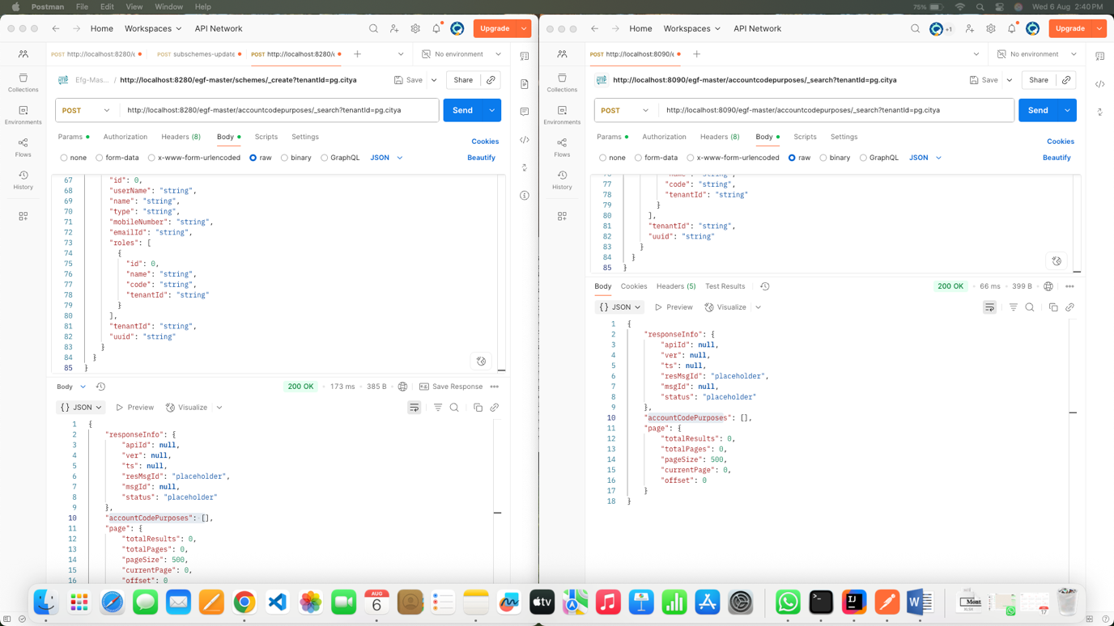

Response compare

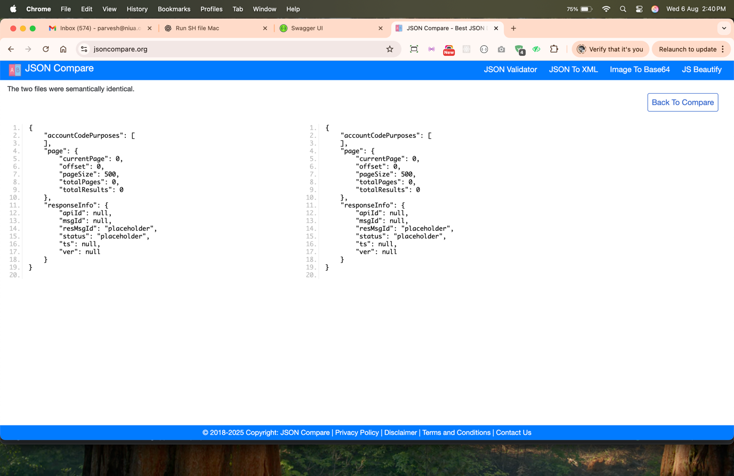

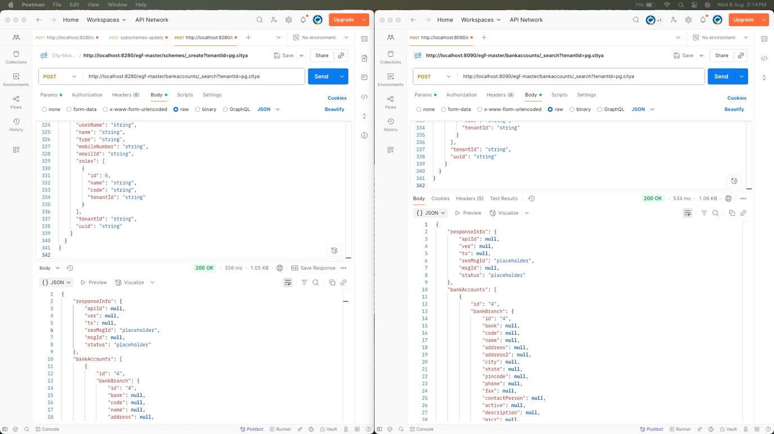

Response compare

